https://github.com/s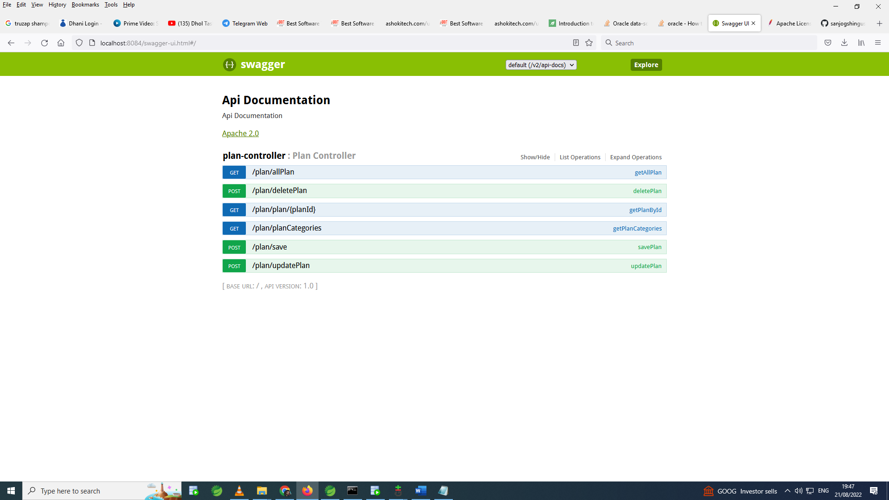anjogshinguste/plan_mini_project.git